Rolling correlation: AUDUSD and USDCAD
Method 05 / daily log returns / windows 20, 60, 100 / Short watchlist

Study setup
Logical pair: AUDUSD , USDCAD
Broker symbols: AUDUSD_i , USDCAD_i
Tier: Short watchlist (short_watchlist)
Snapshot: 2026-11-03_majors_alpari_D1
Timeframe: D1
Matched return window: 1999-01-05 to 2026-11-02 (UTC bar dates)
Matched return count (rows before rolling): 7204
Dropped unfinished last bar dated 2026-11-03 UTC after a tick-volume check against the prior complete day.
Rolling windows W: 20, 60, 100 trading days
Live-shaped n for each score: n = W (not the full history length)
Complete matched rows (CSV): AUDUSD-USDCAD_Rolling_D1.csv
Complete matched rows (HTML): AUDUSD-USDCAD_Rolling_D1_data.html

Method carried forward
Rolling Pearson r is computed on matched daily log returns of close, ln(close_t / close_t-1), in the broker quote direction. Quotes are not inverted. For each day t with a full window, r_W uses the last W matched return pairs ending at t. That live-shaped sample size is W (20, 60, or 100), not the full multi-year history. The first W-1 days have no score. r is symmetric under swap of the two symbols. A high |r| in one window does not prove cause, lead-lag, or a trading signal. Short windows are noisier; long windows are slower to reflect a break.
How to read a live day: after both daily candles close, the newest r_20 uses the last 20 matched log returns, r_60 the last 60, and r_100 the last 100. Compare those three to each other and to the full-sample baseline below. A break is when the short window moves far from the baseline or flips sign while the baseline was meaningful.

Full-sample Pearson baseline (method 01 v001)
Copied full-sample Pearson r for AUDUSD-USDCAD: -0.647362. This is a historical average link, not the live state.

Rolling results
W | latest_r | mean | median | min | max | std | pct_|r|>=0.4 | pct_|r|>=0.7 | n_roll
20 | -0.302206 | -0.592822 | -0.629167 | -0.967097 | 0.660611 | 0.221049 | 82.57 | 36.9 | 7185
60 | -0.526113 | -0.601833 | -0.623556 | -0.907614 | 0.215446 | 0.174298 | 85.86 | 34.65 | 7145
100 | -0.522737 | -0.606591 | -0.626604 | -0.876256 | -0.01701 | 0.160716 | 87.26 | 34.26 | 7105
n_roll is the number of days that had a complete window. pct_|r|>=0.4 and pct_|r|>=0.7 are the share of those days where the absolute rolling correlation cleared the threshold.

Conclusion
For AUDUSD and USDCAD, full-sample Pearson baseline r=-0.6474. Latest rolling scores: r_20=-0.3022, r_60=-0.5261, r_100=-0.5227. Stability: moderate window-to-window variation. Agreement with baseline: r_20=-0.302 far from baseline (0.35); r_60=-0.526 near baseline; r_100=-0.523 near baseline. Tier line: watch — short window has pulled away from the full-sample baseline; treat the link as unstable until windows re-align. This is a monitoring summary, not a trade signal.

What to look at in this file next time
1) Latest r_20 vs r_60 vs r_100 in the results table. 2) Whether short-window latest has the same sign as the baseline. 3) The rolling chart for stretches where |r| collapsed. 4) The CSV if you need a different chart later.

Charts
Rolling Pearson r (20 / 60 / 100)
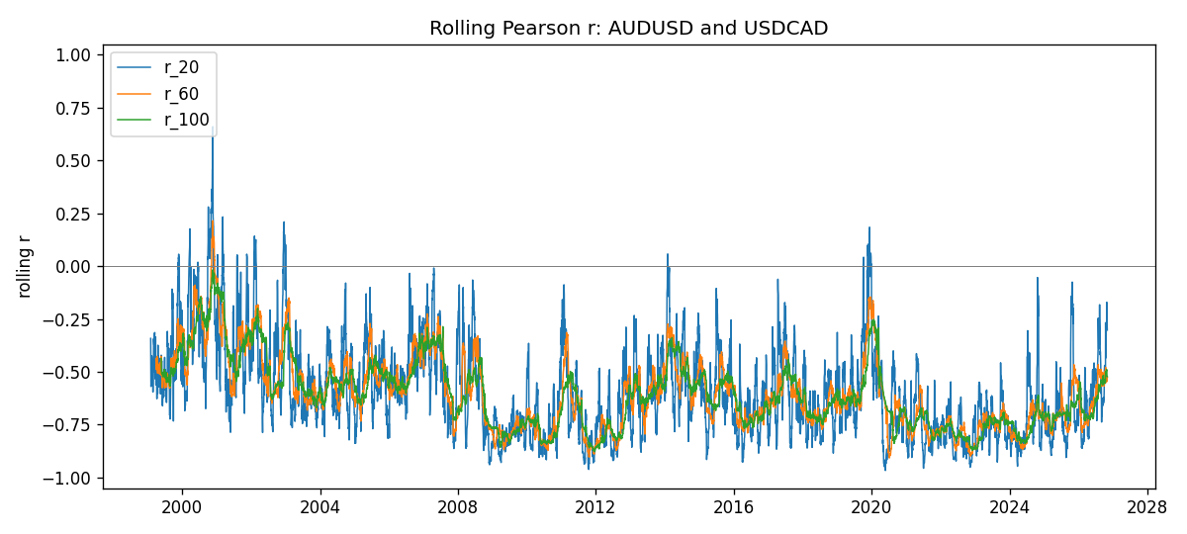
Daily closes

Daily log returns
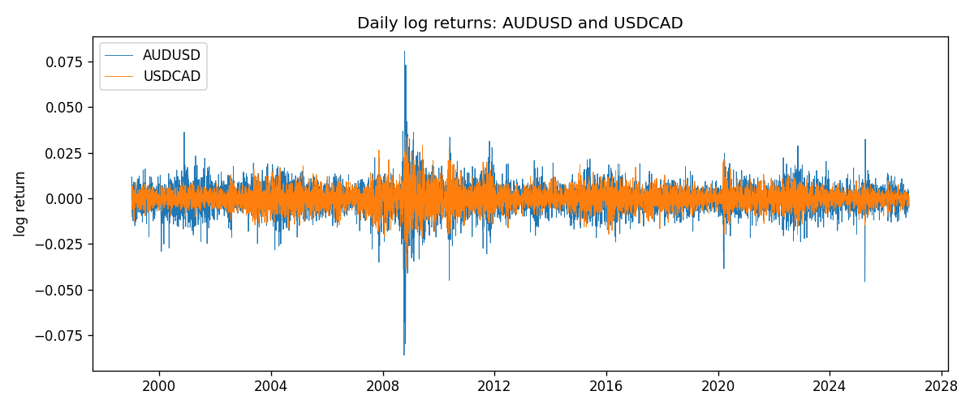

Data report
Every matched row with r_20, r_60, and r_100 is in the sibling CSV and HTML. This Word section holds column summaries and the first and last 15 rows of the rolling table.
Columns: time, AUDUSD_close, USDCAD_close, AUDUSD_tick_volume, USDCAD_tick_volume, AUDUSD_log_return, USDCAD_log_return, r_20, r_60, r_100
Column summaries
column | count | mean | std | min | 25% | 50% | 75% | max
AUDUSD_close | 7204 | 0.751979 | 0.135247 | 0.4786 | 0.661197 | 0.731695 | 0.808875 | 1.10169
USDCAD_close | 7204 | 1.26703 | 0.168973 | 0.916 | 1.11848 | 1.29862 | 1.37251 | 1.6137
AUDUSD_tick_volume | 7204 | 77316.1 | 138115 | 109 | 5421.75 | 43310.5 | 71296.8 | 1.23462e+06
USDCAD_tick_volume | 7204 | 80846.5 | 147184 | 56 | 5511.25 | 40857 | 71531.8 | 1.41082e+06
AUDUSD_log_return | 7204 | 2.007e-05 | 0.0075444 | -0.0860252 | -0.00386183 | 0.00027895 | 0.00414528 | 0.0806166
USDCAD_log_return | 7204 | -1.21e-05 | 0.00514438 | -0.0385975 | -0.00283637 | 4.97e-05 | 0.00272781 | 0.0343632
r_20 | 7185 | -0.592822 | 0.221049 | -0.967097 | -0.761259 | -0.629167 | -0.472511 | 0.660611
r_60 | 7145 | -0.601833 | 0.174298 | -0.907614 | -0.736232 | -0.623556 | -0.503153 | 0.215446
r_100 | 7105 | -0.606591 | 0.160716 | -0.876256 | -0.730313 | -0.626604 | -0.518493 | -0.0170096
First 15 matched rows
time | AUDUSD_close | USDCAD_close | AUDUSD_log_return | USDCAD_log_return | r_20 | r_60 | r_100
1999-01-05 | 0.6215 | 1.5123 | -0.000804182 | -0.0101317
1999-01-06 | 0.6289 | 1.5118 | 0.0118364 | -0.000330677
1999-01-07 | 0.6345 | 1.5141 | 0.00886503 | 0.00152021
1999-01-08 | 0.6347 | 1.511 | 0.000315159 | -0.00204952
1999-01-11 | 0.6393 | 1.5057 | 0.00722138 | -0.00351378
1999-01-12 | 0.6362 | 1.5157 | -0.00486085 | 0.00661947
1999-01-13 | 0.6312 | 1.5226 | -0.00789021 | 0.00454202
1999-01-14 | 0.6295 | 1.5332 | -0.00269692 | 0.00693765
1999-01-15 | 0.634 | 1.5245 | 0.0071231 | -0.00569057
1999-01-18 | 0.6346 | 1.526 | 0.000945925 | 0.000983445
1999-01-19 | 0.6392 | 1.5302 | 0.00722252 | 0.00274851
1999-01-20 | 0.64 | 1.5211 | 0.00125078 | -0.00596469
1999-01-21 | 0.6405 | 1.5146 | 0.000780945 | -0.00428238
1999-01-22 | 0.6327 | 1.5184 | -0.0122527 | 0.00250577
1999-01-25 | 0.6302 | 1.5197 | -0.00395915 | 0.000855798
Last 15 matched rows
time | AUDUSD_close | USDCAD_close | AUDUSD_log_return | USDCAD_log_return | r_20 | r_60 | r_100
2026-10-13 | 0.69821 | 1.4214 | 0.00350077 | -0.00463957 | -0.547416 | -0.536243 | -0.545463
2026-10-14 | 0.69715 | 1.42356 | -0.00151932 | 0.00151848 | -0.494432 | -0.539974 | -0.543929
2026-10-15 | 0.69191 | 1.41843 | -0.00754471 | -0.00361015 | -0.267357 | -0.478867 | -0.498897
2026-10-16 | 0.69426 | 1.41357 | 0.00339064 | -0.00343221 | -0.321249 | -0.491523 | -0.508069
2026-10-19 | 0.6978 | 1.41091 | 0.005086 | -0.00188353 | -0.382999 | -0.504343 | -0.509001
2026-10-20 | 0.70022 | 1.40569 | 0.00346204 | -0.0037066 | -0.433582 | -0.518954 | -0.51512
2026-10-21 | 0.70275 | 1.4045 | 0.00360664 | -0.000846918 | -0.364619 | -0.550546 | -0.503019
2026-10-22 | 0.70186 | 1.40081 | -0.00126726 | -0.00263073 | -0.301429 | -0.531728 | -0.498096
2026-10-23 | 0.70353 | 1.40085 | 0.00237657 | 2.85545e-05 | -0.302875 | -0.531218 | -0.49532
2026-10-26 | 0.70128 | 1.40093 | -0.00320328 | 5.71066e-05 | -0.297653 | -0.519386 | -0.494244
2026-10-27 | 0.70245 | 1.40449 | 0.00166699 | 0.00253795 | -0.233597 | -0.535706 | -0.489355
2026-10-28 | 0.70533 | 1.39911 | 0.00409155 | -0.00383793 | -0.170837 | -0.546302 | -0.501758
2026-10-29 | 0.70245 | 1.39895 | -0.00409155 | -0.000114365 | -0.180907 | -0.543596 | -0.519907
2026-10-30 | 0.70316 | 1.39751 | 0.00101024 | -0.00102987 | -0.25099 | -0.52719 | -0.520987
2026-11-02 | 0.69971 | 1.39837 | -0.0049185 | 0.000615191 | -0.302206 | -0.526113 | -0.522737

